TASK: Investigate the role of these four animals in WWI and complete the boxes below

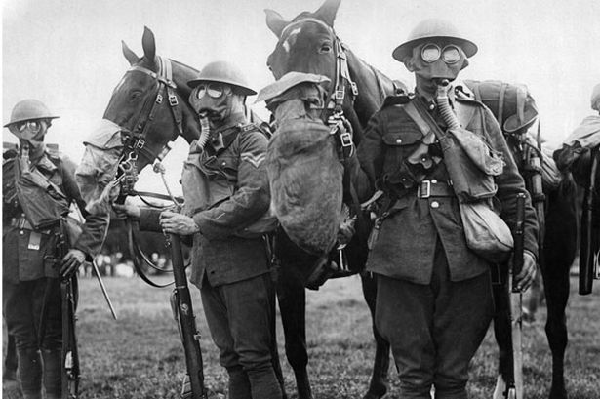 | 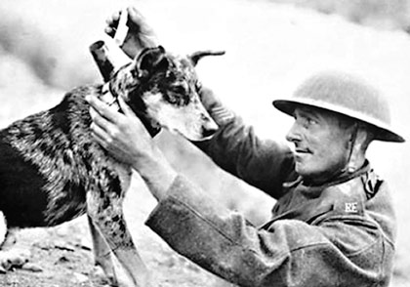
HORSES: | DOGS:
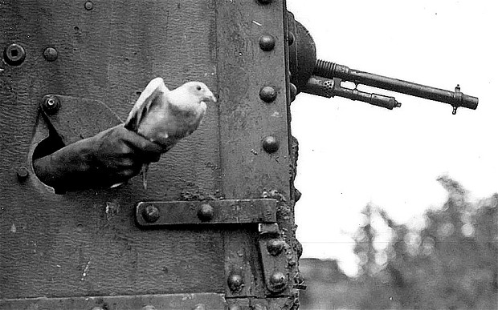 | 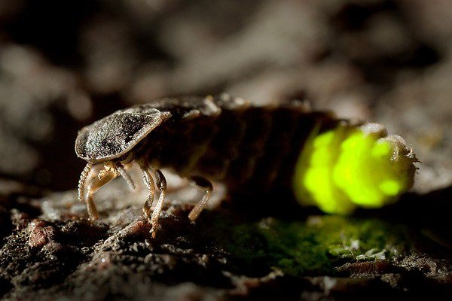
PIGEONS: | GLOWWORMS:

NAME: __________________________
HISTORY Homework
World War One

DEADLINE: _________________________

TASK: Complete the table with the correct dates:
Question | Answer | Question | Answer | Question | Answer
What year did WWI start? |  | How many Dreadnaughts did Germany have in 1914? |  | When was ‘conscription’ introduced?
When was the Triple Alliance signed? |  | How many British soldiers died in WWI |  | How many soldiers are buried at Tyne Cot memorial
When was Franz Ferdinand shot? |  | How many soldiers died in the Battle of Passchendaele? |  | How many British soldiers were wounded in WWI?
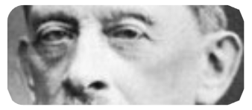
TASK: The Schlieffen Plan

What was the Schlieffen Plan?

What problem did the Plan aim to solve?
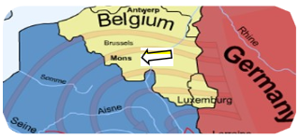
Why did Germany invade Belgium?

Why did the plan fail?

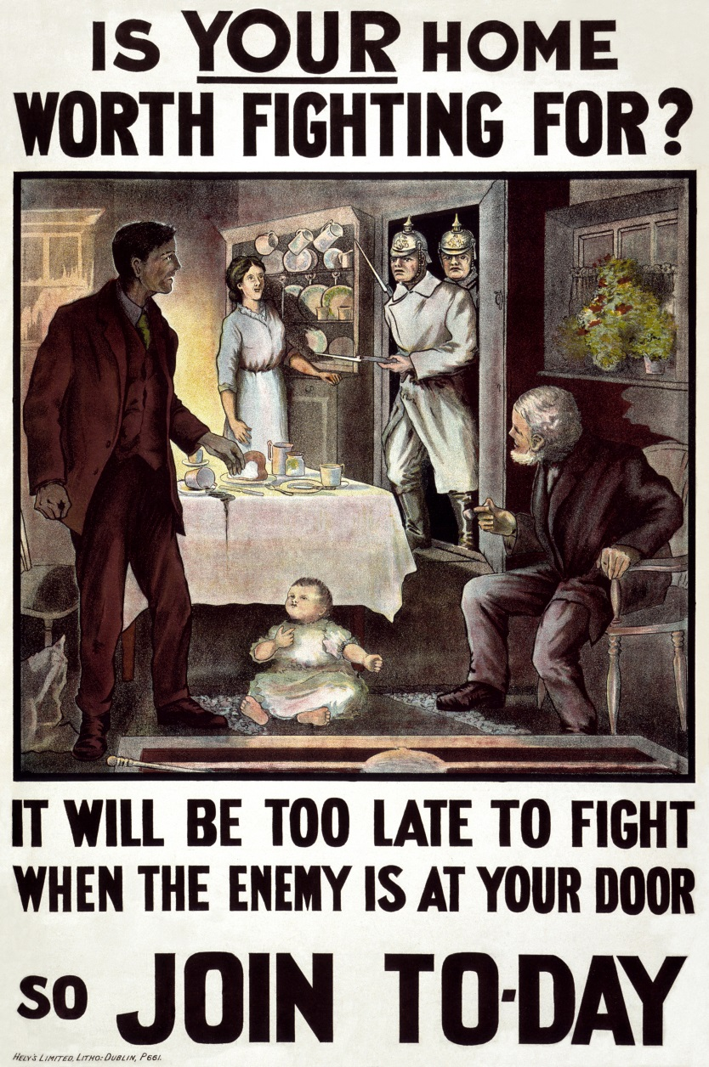
Describe what you can see in the image of the poster? __________________________________________________________________________________________________________________________________________________________________________________________________________________________________________________________________________________

What language techniques are being used to persuade the reader? _________________________________________________________________________________________________________________________________________________________________________________________________________________________________________________________________________________

What do you think is the point of the poster? ________________________________________________________________________________________________________________________

Recruitment Poster, July 1915

TASK: Design your own recruitment poster below:

TASK: Chose a task from one of the four options below
Create a menu based on rations the soldiers would have received in the trenches | Write a newspaper account of the Battle of Passchendaele | Create a poem about why we should still remember WWI 100 years on | Create a model of a trench, including the key areas like dugouts, duckboards etc.

